Module 1: Docker Compose understandings
In this assignment, you will use Docker Compose to define, run, and manage a multi-container application.
You are required to:
- Explain what Docker Compose is and why it is used.
- Create a docker-compose.yml file to run:
- One application service (Node.js / Python / Web app)
- One database service (MySQL / PostgreSQL / MongoDB)

- Configure the following in the Compose file:
- version
- services
- image or build
- ports
- environment
- volumes
- depends_on
- networks
- Build and start the services using:
docker compose up -d

- Verify:
- All containers are running
- The application can connect to the database
- Data persists using Docker volumes
- Stop and remove the setup using:
docker compose down

- Submit the docker-compose.yml file along with a short explanation of each section.
Outcome:
By completing this task, you will understand how Docker Compose simplifies running multi-container applications and how services communicate within a Docker network.
Q1. What is Docker Compose? Why it is used?
Docker Compose is a tool for defining and running multi-container Docker applications using a single YAML file. It simplifies the process of managing complex applications with interconnected services (like a web server and a database) by automating configuration with simple commands.
Docker composed is used to simplify the management of the complex applications composed of multiple interconnected services (for example a web server, a database, a cache, and an api). Instead of using long, complex docker run commands for each container, you define the entire application stack in one human-readable YAML file, which is much easier to manage.
In my case:
The application consists of:
- A Node.js backend application
- A MongoDB database
- A shared Docker network
- Persistent storage using Docker volumes
The system is fully containerized and runs without requiring MongoDB to be installed on the host machine.

Docker Compose Configuration
The docker-compose.yml file is configured with:
version: "3.9"
It defines two main services:

Service: app (Node.js Application)
- Image:
node:18
- Purpose: Runs the backend server
- Port Mapping:
"3000:3000"
This maps port 3000 of the container to port 3000 on the host machine.
Environment Variables:
DB_HOST=db
DB_PORT=27017

These variables allow the Node.js app to connect to the MongoDB container using the service name (db) as the hostname.
- Dependency:
depends_on:
- db
This ensures that the MongoDB container starts before the Node.js application.

Service: db (MongoDB Database)
- image:
mongo:6
- Port Mapping:
“27018:27017”
This maps:
  - Port 27017 inside the container
  - To port 27018 on the host machine
MongoDB runs internally on 27017, but is accessed externally through 27018.
- Volumes:
mongo_data:/data/db
This ensures persistent storage of MongoDB data even if the container is stopped or removed.

Networking Configuration
A custom Docker network is defined:

networks:
mynetwork:

Both services are connected to this network, allowing them to communicate using service names.

For example:

DB_HOST = db

Here, db refers to the MongoDB container within the Docker network.

Volumes Configuration
A named volume is defined:
volumes:
mongo_data:
This volume ensures:
- Database data is not lost when containers restart
- Persistent storage across deployments
- Separation of application and database layers

How the System Works
- Docker Compose starts the db (MongoDB) container.
- Docker Compose starts the app (Node.js) container.
- The Node.js app connects to MongoDB using:
Host: db
Port: 27017
- Users access the application through:
- http://localhost:3000
- MongoDB data is stored persistently using the mongo_data volume.
Step1:- Build and start the services using:- docker compose up -build command

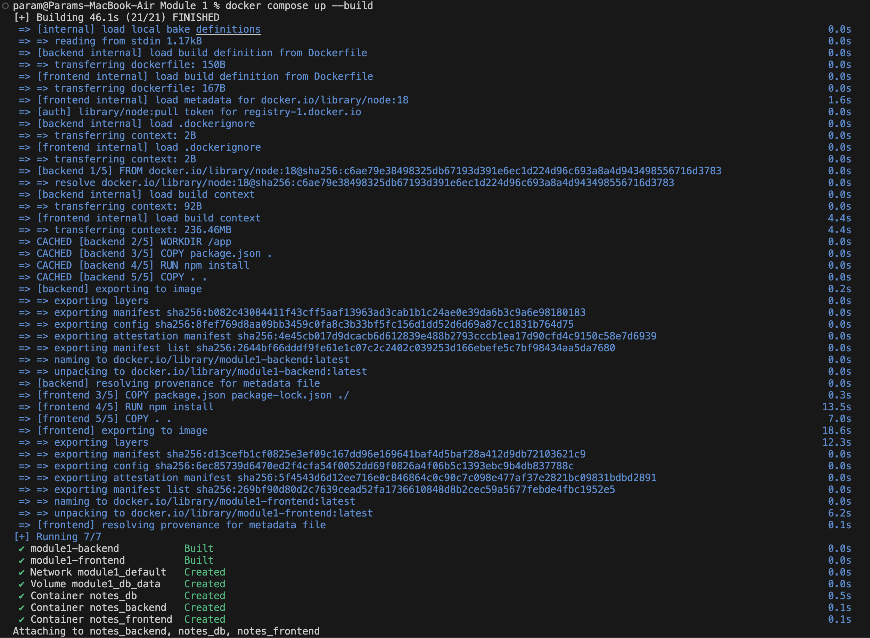
Step2:- Verify using :- docker ps command
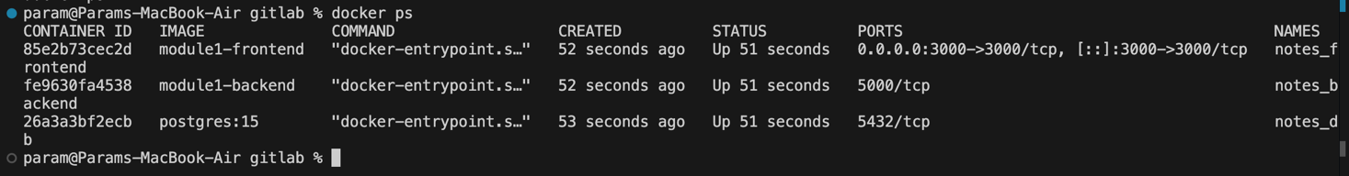

Step3:- Stop and remove the setup using:- docker compose down

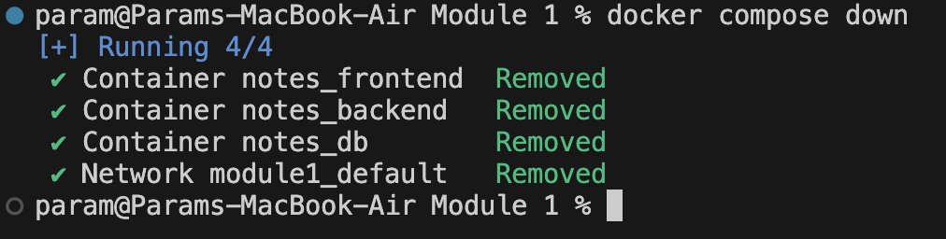

localhost:3000

